
STARFISH MINISTRIES

OCTOBER 2025 NEWSLETTER

WHO WE ARE:
Starfish Ministries, based on The Starfish Story, began with a retired grandmother who had a desire to reach out to the homeless of Harrisburg and supply them with their basic daily needs. While handing out toiletries and snacks, her second desire grew…to give them hope to return to society. The 2nd Sunday of each month we go to the streets of Harrisburg to serve homeless men and women by directing them to support resources, distributing needed items, praying for/with them, all with the personal touch of a hug, a handshake or a listening ear. As paralleled in the Starfish Story, one by one, this is our goal.

Starfish Ministries
89 Broadwell Ln.
Mechanicsburg, PA 17055

On the second Sunday of each month Starfish Ministries is on the streets of Harrisburg handing out basic needs to the homeless. We continue to grow and are now serving approximately 130-145 homeless people in our small city each month with the help of 40 volunteers.

Upcoming Outreach Dates and Main Focus Items:
(held on the 2nd Sunday of each month, 12:30 p.m. to 1:30 p.m., behind Chase Bank in the Square of Harrisburg/behind the Dauphin County Courthouse

- October 12 - long-sleeved T-shirts, leggings, belts, bath towels, bar soap, hoodies
- November 9 - blankets, tarps, winter coats, hand warmers, men’s gloves, winter boots, insulated travel mugs, umbrellas and ponchos, hoodies, sweat pants and jeans
- December 14 - winter coats, thermal underwear, scarves, hats, toothpaste, toothbrushes, OTC cold/flu medications, cough drops
- January 11, 2026 - hand warmers, heavy socks, thermal underwear, vitamins, cold/flu OTC

“Our friends on the street might have less than we do, YET they are no less than we are” Carol Crossley
A MESSAGE FROM CAROL

SUMMARY OF 2025 OUTREACHES TO DATE:
June - Served 156+ grilled hot dogs, house salad, pickled eggs, macaroni salad and pickles Sue Nyce prepared 100+ individually wrapped desserts
July - Served 128 pierogies w/kielbasi and peppers/onions, creamed cucumbers, watermelon & blueberry cake
August - Served 139 grilled hot dogs, cucumber salad, house salad, and pasta salad. Volunteers came from New Cumberland Church of God and Grace UMC, Hummelstown
September - Served 142. Mountain Ridge Church of Dillsburg prepared the meal of pulled pork sandwiches, mac and cheese and baked beans.

THE LATEST NEWS AND UPDATES OF THE HOMELESS COMMUNITY
On July 15th we were invited to be a part of a meeting sponsored by CACHE (Capital Area Coalition on Homelessness) At this meeting the nonprofit group AMiracle4Sure presented that they had recently purchased land and would be developing it for a new homeless community. To explain the reason for this: for years the homeless have made their outdoor homes on land owned by PennDot. This very land will be used for the I83 expansion. The homeless have known this would come at some time and that time is September 23 which is the deadline for them to evacuate their current living spots.

That night Martha Curry-Nixon explained that this land purchased would house 60 individuals/families as soon as it was prepared. The move from PennDot to the Miracle Community was to begin August 1. That night following the meeting John Brassel and I drove to this new spot and frankly were appalled at what we saw. It was a parking lot that had been lined with stones and nothing else. No trees. No shade. Nothing. We walked away disillusioned.

BUT, we were happily wrong. In watching this Miracle Community evolve we have seen good things happening and are very encouraged by this new community. Under the direction of Marsha’s son, Timothy White, they have prepared 14’ x 14’ sites, each housing a large tent on a constructed plywood platform. Each resident is given a cot, a sleeping bag, pillows, solar fans and much more. A mailing address has been established so all the residents now have a mailing address that can be used when applying for jobs or permanent housing, etc. This community comes with rules. Some folks are discouraged by the rules; however, what they bring is safety, security and cleanliness. A pavilion has been provided where there are cooking stations rather than cooking in their tents. Hot water showers are being provided. Plenty of trash cans…porto potties…acknowledged by the Hbg police and fire. I even saw a video where board games have been provided for those who wish to gather in the pavilion for fun fellowship. I WAS TOTALLY WRONG FROM what I initially saw and judged. AMiracle Community is a gift to those unhoused and needing to move from Tent City. UPDATE: CORE who has a shower bus which would provide showers at Tent City every Saturday, has donated their bus and equipment to the Miracle Community! Another win.

Starfish Ministries has provided 3 tents ($170.00 each), 8 pillows, 3 solar fans and a cash donation of $500 for building materials for tent platforms. We are blessed that we have been able to help in this developing community.

What does this move mean for Starfish? We will continue to do our outreach the 2nd Sunday of every month at the same location behind the courthouse. We provide resources to others who don’t live in the tent community. Many live in low income housing, the YMCA, and/or still on the streets. To move our outreach would take away access to so many. Our desire is to continue as we have been doing (If we were to move to the Miracle Community we would not have enough parking and serving space as we sometimes have up to 45 volunteers and 20 tables of donations.) Despite the wonders of this new community, the number of folks coming to our outreaches have not diminished!
M28 MINISTRY (HOUSE2HOME) is one of our biggest suppliers of home furnishings. When other agencies have placed someone into housing they refer their clients to Starfish Ministries. These clients often have nothing but a sleeping bag and a few personal items. Enter House2Home! Everything in their well organized warehouse, from small furniture, beds, kitchen appliances and utensils, etc. are all donated by the public. They simply ask for a $50 donation from each client who “shops” their warehouse. So when you find yourself purchasing new things for your home, please consider reaching out to House2Home to donate your gently used items. www.m28.us

Since June, we have provided furnishings and moves for 6 individuals. Also, with generous donations, we provided a rollator to someone in need, 2 automatic lift chairs, and 3 bicycles for men needing transportation to their jobs.

Daystar Halfway House has been a huge resource for us when we do our “move ins”. Each move in needs “muscle” and “youth” of which we are finding harder to obtain. The folks at Daystar offer us two men for each move in. At the end of each move we give them lunch and a cash gift for their service. Networking is one of the greatest assets to Starfish.

If you or someone you know would like to be added to our mailing list, please send an email to 4starfishministries@gmail.com with your/their name and address.

PLEASE USE OUR COMMUNITY AID PARTNER NUMBER 50218 WHEN MAKING DONATIONS TO COMMUNITY AID! This brings us modest but welcome income.

SPECIAL THANKS....
Starfish Ministries is amazingly blessed by so very many organizations, families and incredible individuals.
- Trinity Church of New Cumberland (my personal church) provides love boxes of food each month, generous monthly financial support and lots of prayers.
- Franklintown United Brethren Church continues to send monthly donations and member volunteers.
- Mission Central of Central PA-monthly donations
- Bethesda Mission Food Bank - drinks and snacks for our bagged lunches
- Christian Life Assembly Food Distribution helps monthly to provide food for the housed Starfish
- Dillsburg Thrift Store (They recently blessed us with a $1000 check)
- Amber Ribera who provides our hot meals each month feeding 140+ folks
- Rick and Kim Breach who prepare the brown bag lunches each month
- Giant Foods for donating $500 in gift cards
- Community Aid who provides $300 in Care Cards each quarter. These cards can be used at their stores to purchase clothing items needed for individuals
- Our many faithful individual donors
- All of our dedicated volunteers!!!

ALWAYS NEEDED: Backpacks SPECIAL REQUESTS
Deodorant NEW underwear Sleeping Bags and Tents
Foot/body powder Canned meats/meals Hand/toe warmers
Tarps (flip tops) Manual can openers
Warm socks Monetary donations Blankets gently used
OTC pharmaceuticals PRAYERS! Thermal underwear

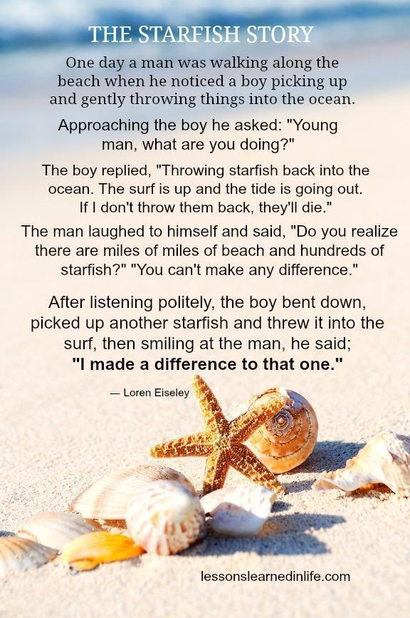
THINGS THAT HAVE KEPT US BUSY SINCE THE LAST NEWSLETTER:
- We facilitated a move after a Starfish received a letter that he had to move (he had been housed for 7 years). Seems his landlord was going to prison for a felony charge and was unable to maintain the residence.
- received a phone call from two young people who had been evicted from their family’s housing. We provided a tent for a while and 2 nights in a motel. Since then they are both working and have become self sufficient
- volunteers gave 3 hours of their time at Community Aid to help with their special sale
- helped a family member on the verge of homelessness by paying a utility bill. Since then she is in great housing with her son and is currently employed.
- assisted a young man with gas who had no money, no gas, no car insurance or inspection.
- consigned many items at Divine Consign in Manheim and Peacock Alley Consignment. The consignment funds are then used to purchase items of need.
- helped with two complete home “clean outs” and were granted many of the items to be used for Starfish
- Visited BOLO (Bread of Life Org) warehouse in Newport to obtain needed donated items
- John and Jim (and sometimes Steve) have been busy picking up donations all over the county
- attended a Community Aid ZOOM meeting relating to our partner expectations
- donated LOTS to Community Aid. REMEMBER TO DO SO ALSO AND USE OUR PARTNER NO. 50218
- participated in a Resource Fair along with 30 other agencies providing help to those in need
- received 3000 pair of Bomba socks and shared with Christian Churches United, Community Cares, 3rd Saturday, UPMC Women’s Street Ministry, Downtown Daily Bread and of course Starfish outreaches!

WAYS YOU MIGHT HELP
*Volunteer to help at a Starfish outreach and bring a friend to introduce them to the joys of community service.
(Sign up on our website under Events)
*Sponsor a Starfish with a tent and sleeping bag ($55)
*Organize a collection at your church or work place for specific items. i.e. foot powder, canned meals, etc.
*Prepare snack bags containing items such as something salty, something sweet, Slim Jims, fruit cups, etc.
*Make sandwiches, bake cookies, cupcakes or brownies

Proverbs: 19:17 “Whoever is kind to the poor lends to the Lord, and he will reward them for what they have done.”

STOLEN: “Hunger is not only for bread; it is also for love. And clothing means also to be clothed in a beautiful dignity. Homelessness means not only the lack of a home made of bricks, but being unwanted, unloved, and uncared for. And this, today, is the greatest homelessness–to be unwanted, unloved and left alone.” V. Antony John Alaharasan, Ph.D.

2025 Starfish Ministries
Sponsorship Opportunities

IF YOU WISH TO DONATE TO STARFISH MINISTRIES You can now do so via PayPal, Venmo, (see address below) OR simply mail your check made payable to Starfish Ministries and return to Carol Crossley, 89 Broadwell Ln, Mechanicsburg PA 17055. All donations are used for helping our friends on the street. Thank you from the bottom of our hearts for caring for them! Prayers for all, that you and your loved ones remain safe from harm.

The King will reply, ‘Truly I tell you, whatever you did for one of the least of these brothers and sisters of mine, you did for me.’ ~Matthew 25:40

Please complete the form below and return it to Carol Crossley at the following address or send via email to 4starfishministries@gmail.com Return envelope enclosed

Starfish Ministries
Attn: Carol Crossley
89 Broadwell Lane
Mechanicsburg, PA 17055

Name:_____________________________________________________________________

Address: ___________________________________________________________________

Phone No. and Email Address: ___________________________________________________

Sponsorship level: ❑ Gold ($750+) will supply one month’s outreach items needed
❑ Silver ($200) will buy 3 tents , 3 sleeping bags and 3 tarps
❑ Bronze ($175) will cover one complete “move in” (H2H, Uhaul, Daystar)
❑ $150 will provide the monthly donation for the Mobile Barbershop
❑ $75 buys gas for the Starfish van to pick up collections, do “move ins”, and helps
with the monthly outreach
❑ $55 will provide an essential tent and sleeping bag
❑ $45 will provide monthly electricity for the garage
❑ $35 will purchase one tent
❑ To be used where needed the most __________
❑ Make my gift monthly because the need and the work is ongoing. Thank you!

Payment type: ❑ Check (enclosed) Check #__________________________________
Made payable to “Starfish Ministries”

Venmo/Paypal www.venmo.com/Carol-Crossley-2 OR
www.paypal.me/starfishministries

THANK YOU FOR SUPPORTING STARFISH MINISTRIES

Compassion in Action
for our unhoused friends on the street

Starfish Ministries
89 Broadwell Ln.
Mechanicsburg, PA 17055

Carol Crossley, Founder/Director
Phone: 717-379-9030
Starfish email: 4starfishministries@gmail.com
Stay informed at: www.facebook.com/starfishministries.hbg
Website: www.starfishministrieshbg.org

If you wish to be taken off of our mailing list, please text “remove,” and your name to 717-379-9030
Tax ID No. 83-4362989
A 501(c)3 non-profit organization

